INVENTORY ANALYSIS QUERIES
Seller and Inventory Management System
1. Aim
To analyze inventory records using SQL queries and generate reports about product availability and stock quantities.
2. Introduction
Inventory analysis helps an e-commerce business understand the available stock of products. It provides information about total products, out-of-stock products, highest stocked products, and average inventory quantity.
3. Reports Generated
3.1 Total Products Available
This report displays the total number of different products available in the inventory.
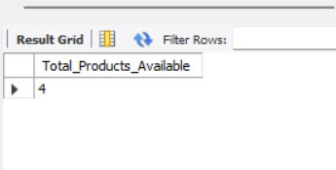

3.2 Products Out of Stock
This report identifies products whose stock quantity is zero.
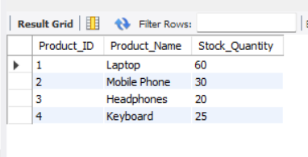

3.3 Highest Stocked Products
This report identifies the products with the highest stock quantity.
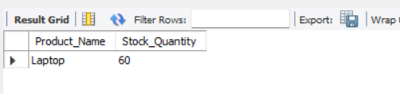

3.4 Average Inventory Quantity
This report calculates the average stock quantity of inventory records.
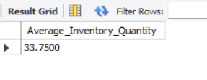

4. SQL Concepts Used
- SELECT
- JOIN
- COUNT()
- AVG()
- MAX()
- WHERE
5. Importance of Inventory Analysis
- Helps monitor available stock.
- Identifies products that are out of stock.
- Helps businesses understand stock levels.
- Supports inventory planning and management.
6. Result
Thus, inventory analysis queries were created successfully to analyze product stock and generate useful inventory reports.

